**MDF Rose Engine Lathe 2.0**

**with Stepper Motor Drive**



**Instructions for Building**

**Control System for**

**Multiple Stepper Motors**

**Part 3 – Electronics**

**Version 3.1**

**19 October 2021**

Permission is not granted to manufacture these for sale.

Table of Contents

Overview of Connections 4

Bill of Materials 5

Section 1 – Printed Circuit Board 11

Section 1 Addendum - Nextion Intelligent Display and Teensy 3.6 20

Section 2 – Power Cables 21

Section 3 – Stepper Motor Driver Signal Cables 25

Switch Settings 27

Section 4 – Nextion Display Signal Cable 28

Section 5 – Limit Switch Signal Cables 31

Section 6 – Final PCB Steps 33

Section 7 – Stepper Motor Cables 34

Section 8 – Assembly of the Nextion touch screen Box 36

Attach Nextion Display to the Bezel 36

Section 9 – System Setup and Program Loading 40

Section 10 – Finishing It Up 40

Optional Configurations 41

Option 1: Less Functional Model 41

Option 2: Alternative Stepper Motor Drivers 42

Option 3: Different Microcontroller 43

Option 4: Different Display 44

Document Version History 45

# Overview of Connections

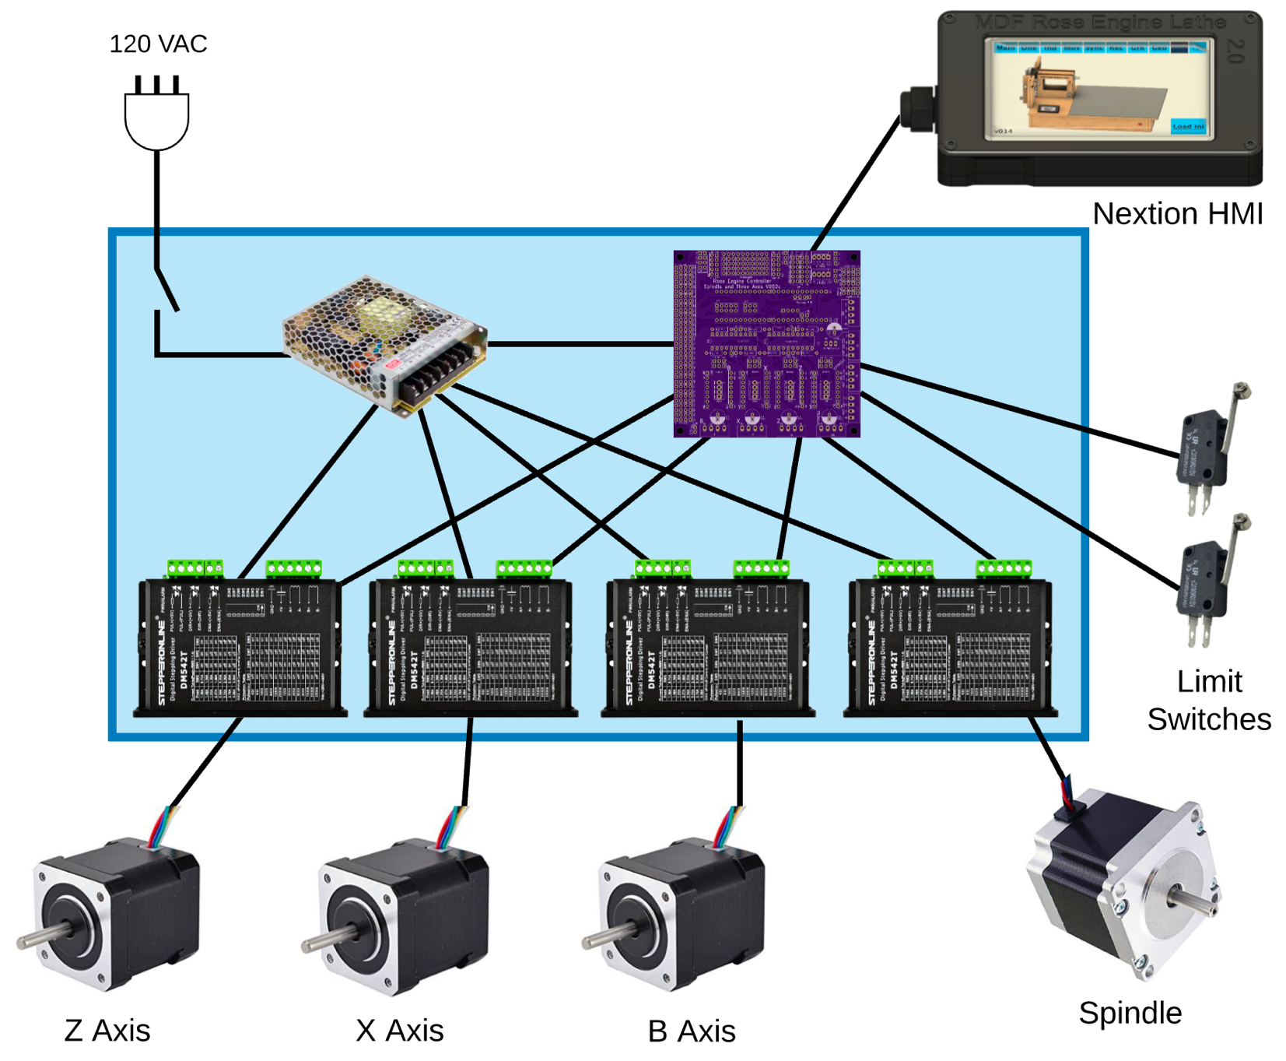The whole system is shown in the picture below.

*Can be added later*

*Can be added later*

The details for how we are building the one you can buy are below. These are documented for our use to ensure consistency, and we are publishing them for anyone who wishes to build their own.

The sequence of activities follows the layout of this document. That was done consciously. Changes to the sequence should be considered strongly before making changes.

|  |
| --- |
| Bill of Materials |

Parts required for building this are below. The item numbers are shown in the following drawings using an orange, circled number like the one to the right.

| Item # | Item | Qty | Source | Source  Part Number | Comments |
| --- | --- | --- | --- | --- | --- |
|  | **Printed Circuit Board Assembly** |  |  |  |  |
| 101 | Printed Circuit Board (PCB) | 1 | OSH Park | 4Rose_002c_Gerbers copy |  |
| 102 | Header Sockets | 2 | Digi-Key | S7022-ND | 24 pins each  Mfgr p/n PPTC241LFBN-RC |
| 103 | 20-pin DIP sockets | 2 | Digi-Key | ED3054-5-ND |  |
| 104 | 10 KΩ resistors | 8 | Digi-Key | CF14JT10K0CT-ND |  |
| 105 | 100 µF electrolytic capacitor | 1 | LCSC | C59414 | Mfgr p/n KM101M050F115A |
| 106 | 74HCT245 Octal Bus Transceiver, 3-state | 2 | Digi-Key | 296-1612-5-ND |  |
| 107 | R-78E5.0-1.0 DC/DC Converter | 1 | Digi-Key | 945-2201-ND |  |
| 108 | Teensy 3.5 | 1 | PJRC | Teensy 3.5 pins | Be sure to get the one with the pins already soldered into place. |
| 111 | Header Connector, Vertical, 4 pins, 2.54mm pin spacing | 5 | Digi-Key | WM4113-ND | Used to connect the PCB to:   * Stepper motor drivers (4) * Nextion Display (1)   Molex p/n 0022272041 |
| 112 | Header Connector, 90 degree, 4 pins, 3.50mm pin spacing | 1 | Digi-Key | 277-2419-ND | Used to connect power to the PCB.  Phoenix Contact p/n 1844236 |
| 113 | Header Connector, Vertical, 12 pins (6x2), 2.54mm pin spacing | 1 | Digi-Key | 609-5695-ND | Used to connect jacks for limit switches to the PCB.  Amphenol ICC p/n 77313-101-12LF |
| 114 | Header Connector, Vertical, 2 pins, 2.54mm pin spacing | 1 | Digi-Key | SAM12303-ND | Used for setting the power selection for the Nextion touch screen.  Samtec p/n TSW-102-24-T-S |
| 115 | Mini Jumper | 1 | Digi-Key | 664-G89011020023DEU-ND | Used for setting the power selection for the Nextion touch screen.  Amphenol p/n G89011020023DEU.  **NOTE**: If using the V002i PCB, then 5 will be needed. |
| 116 | Header Connector, Vertical, 4 pins (1x4), 2.54mm pin spacing | 4 | Digi-Key | 609-5676-ND | Used on V002i PCB to enable use of resistors.  Amphenol ICC p/n 77311-101-04LF.  **NOTE**: Only needed if using the V002i PCB. |
| 117 | Header Connector, Vertical, 4 pins (2x2), 2.54mm pin spacing | 1 | Digi-Key | 609-5691-ND | Optional: Can be used to connect jacks for limit switches to the PCB. Amphenol ICC p/n 77313-101-04LF. |

| Item # | Item | Qty | Source | Source  Part Number | Comments |
| --- | --- | --- | --- | --- | --- |
|  | **Electrical Items** |  |  |  |  |
| 201 | AC/DC Power Supply - LRS-100-24 | 1 | Digi-Key | 1866-3314-ND |  |
| 202 | DM542T Stepper Driver | 4 | StepperOnline | DM542T |  |
| 203 | Nextion 4.3” HMI Enhanced | 1 | ITEAD.cc | NX4827K043 | If that model is not available, select the replacement which has:   * Resistive touch (vs. capacitance) * Flash data storage space: 32MB or more * EEPROM: 1024 bytes or more * RAM: 8192 bytes or more * Instruction buffer: 1024 bytes or more * Resolution: 480×272 pixel |
| 204 | Terminal Block, 10 circuits, low profile | 1 | Mouser | 538-39100-1910 | Used to distribute power from the LRS-100-24 (#201) to the other parts in the box.  Molex p/n 39100-1910 |
| 205 | Power Switch | 1 |  |  | SPST Toggle |
| 206 | GX-16/ 4 Socket | 4 | Amazon |  | Used to connect stepper motors to stepper motor drives.  May come as a pair of sockets and plugs (i.e., including #214) |
| 207 | 3.5mm Audio Jack, Female | 6 |  |  | Used for connecting limit switches. |
| 212 | Cord Grip | 1 | McMaster-Carr | 69915K47 | Used for the cable to the 3D-printed case for the Nextion display. If hard wiring the cable to the main box, a 2d one of these is needed. |
| 213 | Stepper Motor | 1 | StepperOnline | 23HS30-30045 | For the spindle drive: NEMA 23 bipolar 1.8°, 1.9 Nm, 2.8A, 3.2V, 57mm x 57mm x 76 mm |
| 214 | GX-16/ 4 Plug | 1 | Amazon |  | Used for stepper motors.  May come as a pair of sockets and plugs (i.e., including #206) |
| 215 | GX-12/ 4 Socket | 1 | Amazon |  | Used for the Nextion touch screen display.  May come as a pair of sockets and plugs (i.e., including #216) |
| 216 | GX-12/ 4 Plug | 1 | Amazon |  | Used for the Nextion touch screen display in lieu of RJ-45 connectors.  May come as a pair of sockets and plugs (i.e., including #215) |
| 217 | Connector Housing Receptacle, 2.54mm pin spacing | 5 | Digi-Key | WM2002-ND | Used to connect the PCB to:   * Stepper motor drivers (4) * Nextion Display (1)   Molex p/n 0022013047 |
| 218 | Terminal Block Plug, 4 pins, Screw Terminals, 3.50mm pin spacing | 1 | Digi-Key | 277-2418-ND | Used to connect power to the PCB.  Phoenix Contact p/n 1840382 |

| Item # | Item | Qty | Source | Source  Part Number | Comments |
| --- | --- | --- | --- | --- | --- |
|  | **Cables** |  |  |  |  |
| 301 | Cabling – CAT 5 or higher |  |  |  | Used for the Nextion touch screen. |
| 302 | Cabling – 20 AWG/4, stranded |  |  |  | Used for signaling for the stepper motors and the stepper motor drivers. |
| 303 | Cabling – 20 or 22 AWG/2, stranded or solid core |  |  |  | Used for low voltage, DC power. |
| 304 | Cabling – 16 AWG/3, stranded |  |  |  | Used for AC power. Can cut off the female end of a grounded extension cord. |
| 305 | Cable with Connector, 2 pin, 2.54mm pin spacing, 500mm long (19 ½”) | 3 | Digi-Key | 1175-1261-ND | Used for limit switches. Both ends have connectors, so cable will be cut in the center to make two each.  CNC Tech p/n 810-10053-00050 |
|  | Cable, pre-crimped on one end for Molex connector (#217), 10” long, 28 AWG, |  |  |  | Used to connect the PCB to the GX-12/4 socket for the Nextion touch screen. |
| 306 | * White | 1 | Digi-Key | 0008500113-10-W8-ND | Molex p/n 08500113-10-W8 |
| 307 | * Orange | 1 | Digi-Key | 0008500113-10-A8-ND | Molex p/n 08500113-10-A8 |
| 308 | * Green | 1 | Digi-Key | 0008500113-10-G8-ND | Molex p/n 08500113-10-G8 |
| 309 | * Blue | 1 | Digi-Key | 0008500113-10-L8-ND | Molex p/n 08500113-10-L8 |
| 310 | Crimp Terminal | 16 | Digi-Key | WM2312-ND | Used to connect the PCB to the DM542T stepper motor drivers.  Molex p/n 08550102 |

| Item # | Item | Qty | Source | Source  Part Number | Comments |
| --- | --- | --- | --- | --- | --- |
|  | **Screws, etc.** |  |  |  |  |
| 402 | Brass Heat-Set Inserts for Plastic, #4-40, 0.170” | 4 | McMaster-Carr | 94459A260 | If you take option #1 as outlined on pg. 37, you should use these. If not, they are not needed. These go with #403, below. |
| 403 | Screws, #4-40, ¾” | 4 | McMaster-Carr | 97763A322 | If you take option #1 as outlined on pg. 37, you should use these. If not, they are not needed. These go with #402, above. |
| 404 | M3 Screws, Thread Forming | 4 | McMaster-Carr | 96817A300 | Used to attach the Nextion touch screen display to the 3D printed case. |
| 405 | Magnets | 4 | McMaster-Carr  or Amazon | 5862K14 | ½” outside diameter with hole in center for attaching to an object via a screw. Used on bottom of the 3D-printed enclosure for the Nextion touch screen display |
| 409 | Sheet metal screws, #4, 5/16” long, flat head |  | McMaster-Carr | 90065A107 | Used to attach #405 magnets to the 3D-printed enclosure for the Nextion touch screen display. |
| 410 | Torx Round Head Thread-Forming Screws for Plastic, #4, 7/8” long |  | McMaster-Carr | 96001A217 | If you take option #2 as outlined on pg. 37, you should use these. If not, they are not needed. |

| Item # | Item | Qty | Source | Source  Part Number | Comments |
| --- | --- | --- | --- | --- | --- |
|  | **Touch Screen Parts** |  |  |  |  |
| 601 | Touch Screen Case, 3D printed | 1 | Colvin Tools |  | Can also get plans to 3D print this from **elfren**’s repository on GitHub. The folder is  **RoseEngine_SpindleAndAxis / Nextion / Enclosure_43**  Alternatively, the 3D printing designs are at <https://mdfre2.colvintools.com/3DPrint.html>. |

Not all screws are shown, only the ones which matter for size or are hard to find.

| Item # | Item | Qty | Source | Source  Part Number | Comments |
| --- | --- | --- | --- | --- | --- |
|  | **Optional Parts** |  |  |  |  |
| 901 | Limit switch | Up to 6 | McMaster-Carr | 7779K13 | Needs to be normally off with a momentary on. |
| 902 | Magnetic Base Stand with Noga Arm |  | Amazon |  | For holding the limit switch. Clockwise Tools MGBR-01 is a good one to consider. |
| 903 | microSD extender |  | Amazon |  | Needs to provide a male jack to plug into the Teensy, and a female jack for inserting the microSD card.  Recommend one with a cable which is 10” to 12”. |

|  |
| --- |
| Section 1 – Printed Circuit Board |



Attach the parts to the **Rose Engine Controller Spindle and Three Axes V002c** printed circuit board (PCB) using the instructions below.

If you are using the **Rose Engine Controller Spindle and Three Axes V002i** printed circuit board, it will be similar, but the differences are noted in the instructions.

Once all the parts are in place, it will look like this

(the color difference between this and the following pages is due to the camera flash on my iPhone)

### Printed Circuit Board (PCB) versions

|  |  |
| --- | --- |
| **Version 002c** | **Version 002i** |
|  |  |

### Through-Hole Components, part 1

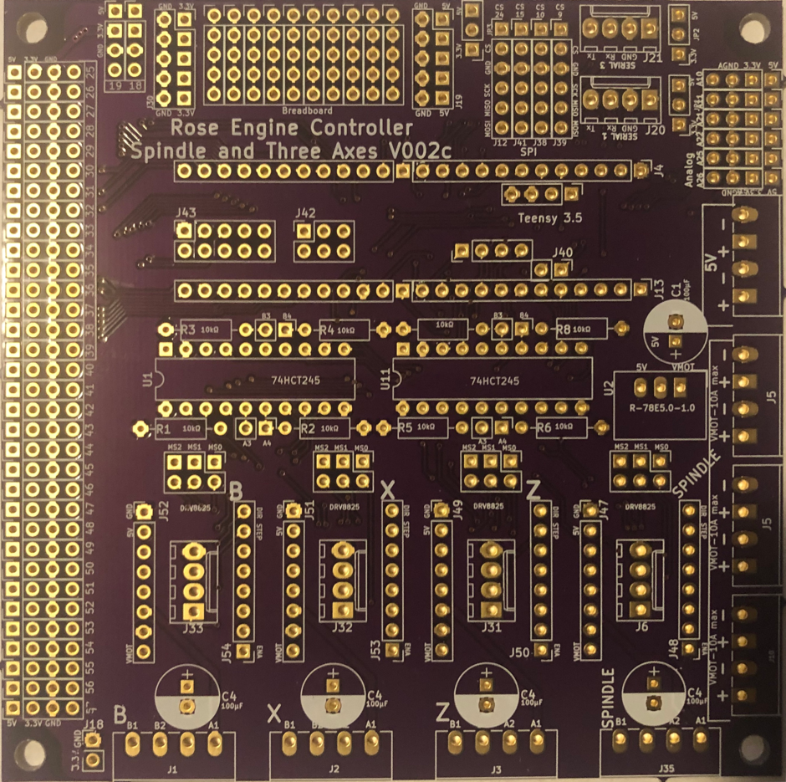Solder in the resistors as noted below.

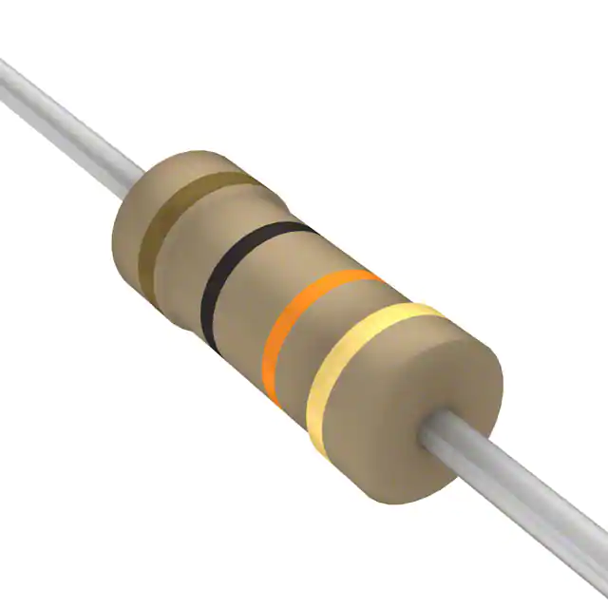

10 KΩ resistors (8)

**NOTE 1:** If you will be using a Nextion Intelligent display (i.e., the 7” one), then the four (4) resistors on the right (R5, R6, R7, & R8) should not be added.

**NOTE 2:** the direction in which these are installed is not critical, but I solder them in place the same for each side. Makes it look more dress-right-dress. (My SGT would be happy.)

If you are using the version 002i PCB, follow these instructions; otherwise, continue to the next page.

Solder in the 4 headers for bypassing the resistors. These are installed for JP10 – JP17. Add mini-jumpers for JP10, JP11, JP12, & JP13 (for the 74HCT245 on the left side of the board.

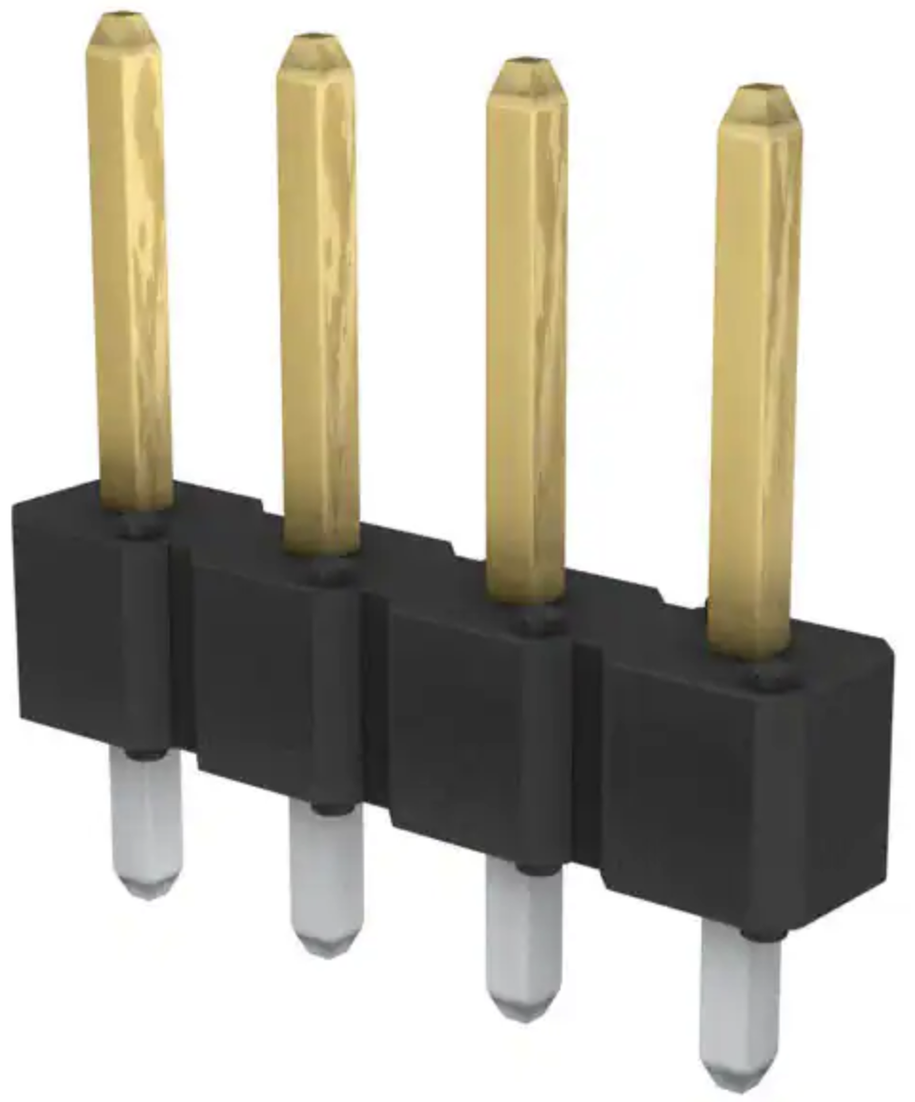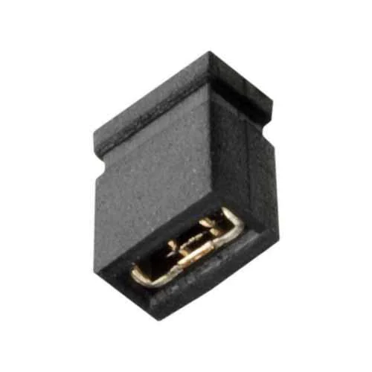

Header Connector, vertical, 4 pins (1x4), 2.54mm pin spacing

Mini Jumper – Installed across pins in header connector #116.

**NOTES:** If you choose to use Serial 3 instead of Serial 1 for connecting the Nextion display, connect the mini-jumpers as noted to the left.

**NOTE 2:** No jumpers here when using Serial 3.

**NOTE 1:** Jumpers here when using Serial 1 (default).

**NOTE 3:** No jumpers here when using Serial 1 (default).

**NOTE 4:** Jumpers here when using Serial 3.

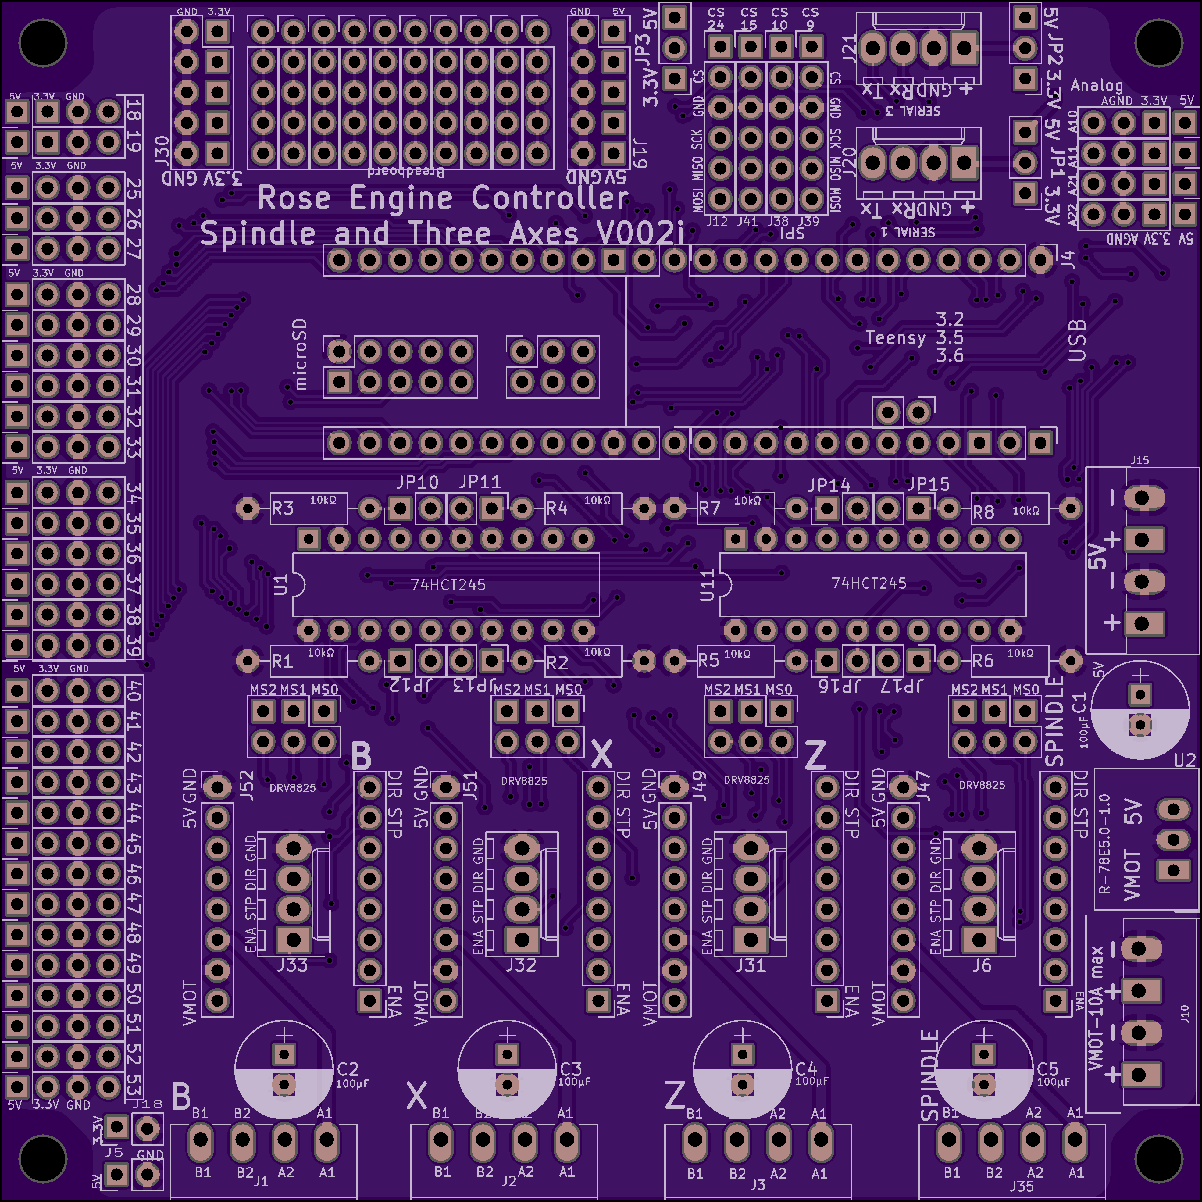

### Headers for Integrated Circuits

Solder in the 2 headers for the Teensy, and the 2 DIP sockets for the integrated circuits.

Headers (2) for Teensy 3.5

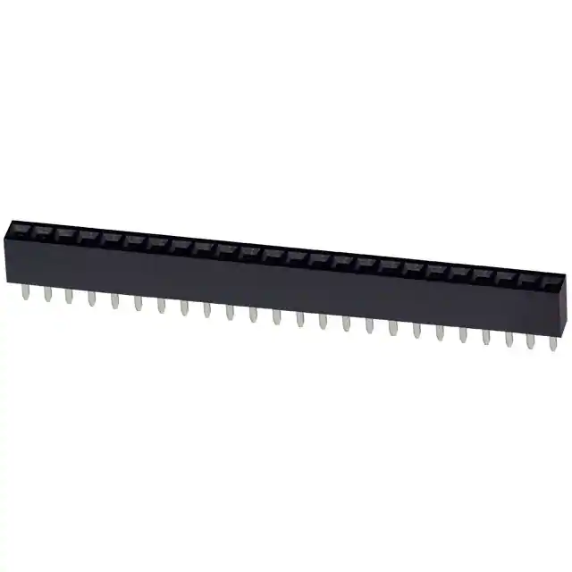

20-pin DIP sockets (2) for 74HCT245s

**NOTE:** The headers must be at 90° to the circuit board. It is necessary to ensure that they remain perpendicular

or the Teensy’s pins will

not fit into the

header pin holes.

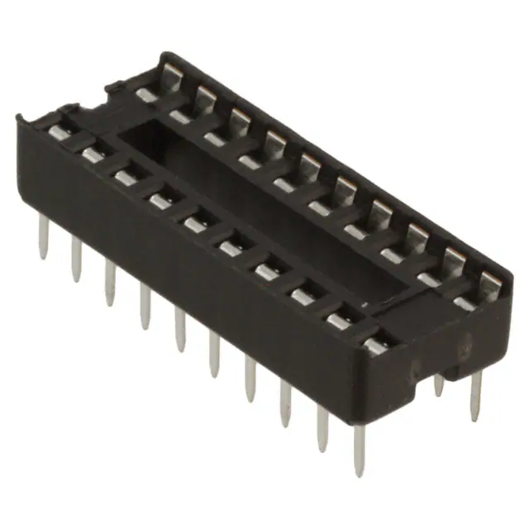

**NOTE:** Both sockets have direction indicators on them. Ensure they match the direction indicators on the board (the little curved part of the marking on the board). This is to ensure the 74HCT245s are inserted correctly.

### Power Header Connector

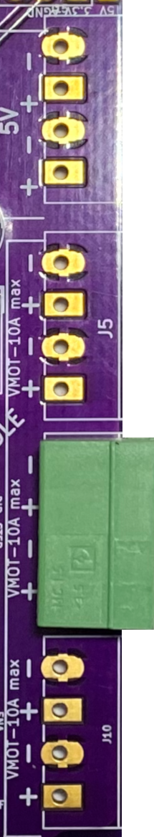Solder in the power connector as noted below.

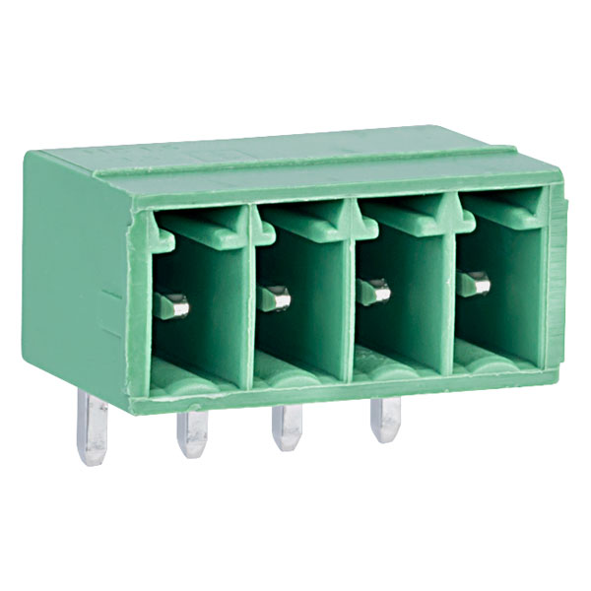

Header Connector, 90 degree, 4 pins, 3.50mm pin spacing

**NOTE 3:** The connector’s pins (the side shown above) should point toward the outside of the PCB.

**NOTE 1:** Either J5 could be used. Using this one makes later work easier.

**NOTE 2:** On the V002i PCB, this is labelled as J10.

**As Installed**

### Nextion Display Header Connectors

Header Connector, vertical, 2 pins, 2.54mm pin spacing

Solder in the power and signal connector for Serial 1 as noted below.

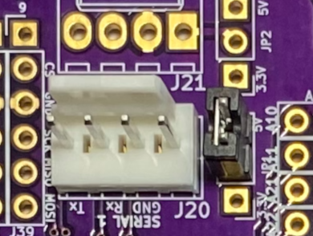

Mini Jumper – Installed across pins in header connector #114.

**NOTE 1:** The plastic tab projecting up from the connector should be aligned with this marking on the PCB.



Header Connector, vertical, 4 pins, 2.54mm pin spacing



**As Installed**

**NOTE 2:** If you are using. The V002c PCB, a Teensy 3.6, and a Nextion Intelligent display (or plan to do so), these two connectors are not needed; proceed to the next step.

### Stepper Motor Driver Header Connectors

Header Connector, vertical, 4 pins, 2.54mm pin spacing

Solder in the stepper motor driver connectors as noted below.

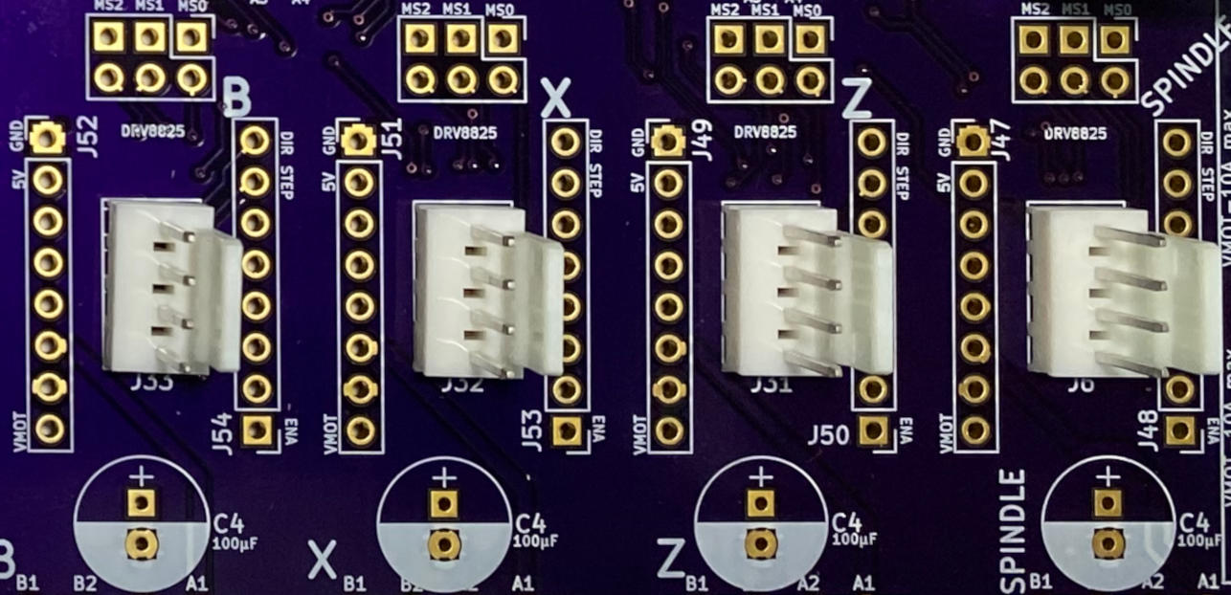



**As Installed**

**NOTE:** The plastic tab projecting up from the connector should be aligned with this marking on the PCB.



### Limit Switch Header Connectors

**NOTE 2:** A second connector is used on pins 34-39.

**NOTE1 :** One connector is used on pins 25-30.

Solder in the limit switch connector pins as noted below.



The original design only used pins 34-39; however, this board and the Teensy can use pins 18, 19, and 25-39.

If you choose to connect a microSD extender to the Teensy, pins 29-37 need to be left unused or the limit switch connectors will interfere.

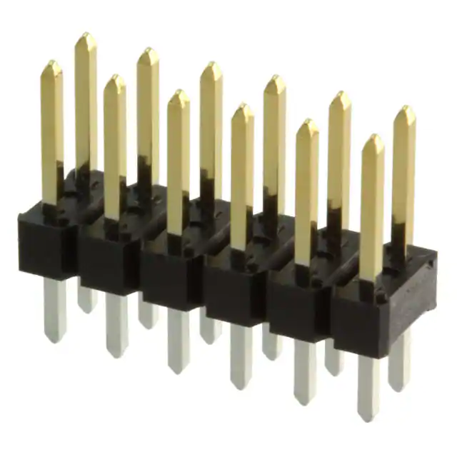

**As Installed**

Header Connector, vertical, 12 pins (6x2), 2.54mm pin spacing

| **Pins** | **PCB V002c** | **PCB V002i** |
| --- | --- | --- |
| 18 – 19 | 77313-101-04LF, or  leave unused | 77313-101-04LF |
| 20 – 24 | *n/a* | *n/a* |
| 25 – 30 | 77313-101-12LF | *(leave unused)* |
| 31 – 33 | *(leave unused)* | *(leave unused)* |
| 34 – 39 | 77313-101-12LF | 77313-101-12LF |

Amphenol ICC part number to use

### 

**NOTE 1:** Be sure the capacitor is set correctly. The negative (–) side goes in the area shaded white.

### Through-Hole Components, part 2

Solder in the components noted below.

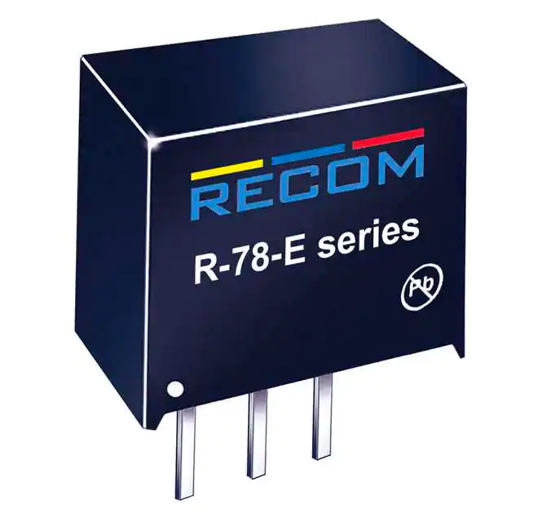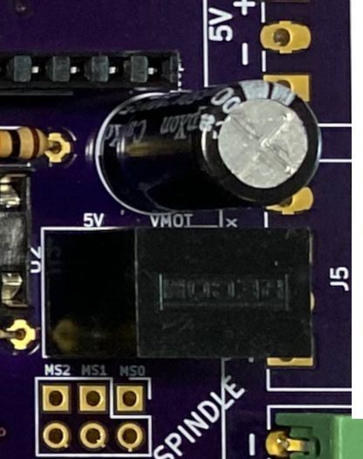

R-78E5.0-1.0 DC DC Converter

**As Installed**

100 µF Capacitor

**As Installed**

**NOTE 3:** On the V002i PCB, the placement on the board is slightly different, but is marked similarly none-the-less.

**NOTE 2:** The DC converter should fit over the box printed for it on the board.

Once all the parts are in place, it will look like this.

(the color difference is due to the camera flash on my iPhone)

|  |
| --- |
| Section 1 Addendum - Nextion Intelligent Display and Teensy 3.6 |

When using the **Teensy 3.6** with a **Nextion Intelligent** series display, there is a concern that the Nextion HMI could supply 5V back to the Teensy. The Teensy 3.5 can handle 5V; however, the Teensy 3.6 can only handle 3.3V so some additional wiring is needed.

Based on the printed circuit board & Nextion display you are using, additional wiring may be needed. The decision table below shows you how to decide.

|  |  |  |
| --- | --- | --- |
|  | **PCB version V002c** | **PCB version V002i** |
| Nextion Enhanced Series Display | No change needed – proceed to Section 2 | No change needed – proceed to Section 2 |
| Nextion Intelligent Series Display | Follow the directions on the following pages. | No change needed – proceed to Section 2 |

The purple boards shown are from OSH Park. Boards from Seed Studio may be a different colour.

If that is the approach you are using, an additional header connector and additional wiring is recommended on the PCB as noted below. This is for use of Serial 1. If you use Serial 3, then the wires should be connected to the PCB in the area that is appropriate.



Add a new header connector at this location for connecting the Nextion Intelligent display to the PCB. These are breadboard wiring locations, and each vertical row is connected in the PCB.

Also, remove these 4 resistors.

Recommend removing this header connector.

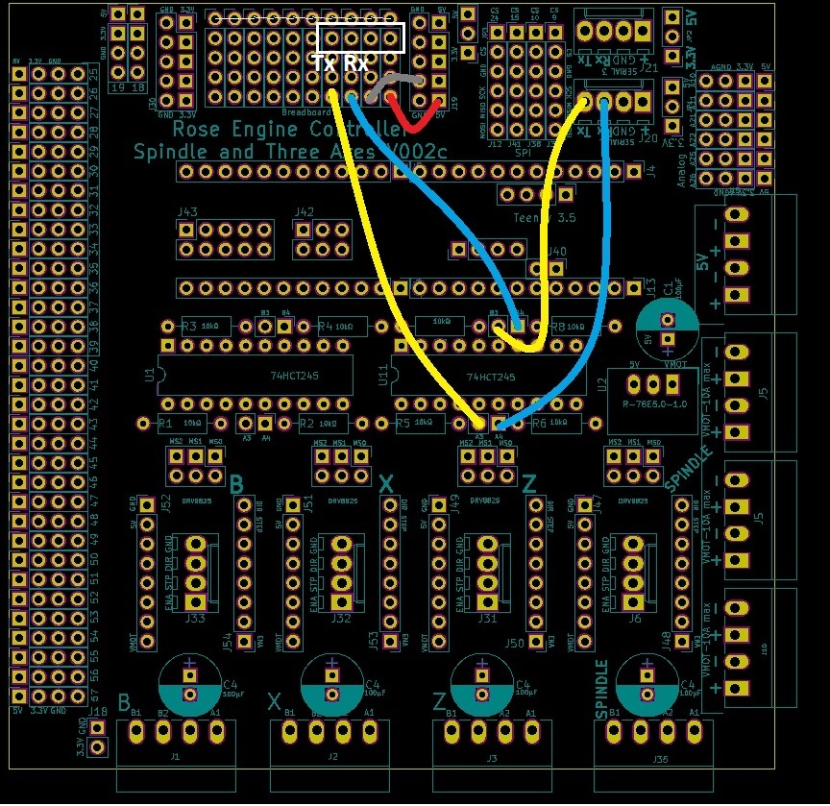

**NOTE 1:** Wiring is shown from the front of the PCB but is usually installed on the back.

**NOTE 2:** There are 6 wires shown:

* 2 blue (RX),
* 2 yellow (TX),
* 1 red (+5V), and
* 1 gray/white (GND).

|  |  |  |
| --- | --- | --- |
| **74HCT245 Function Table** | | |
| **Control Inputs** | | **Operation** |
| **Output Enable** | **Direction** |
| L | L | Data Transmitted from Bus B to Bus A |
| L | H | Data Transmitted from Bus A to Bus B |
| H | X | Buses Isolated (High-Impedance State) |

The basis for this wiring is that the data bus transceiver (74HCT245) can be used to ensure the Teensy is not overloaded by the Nextion’s transmissions.

The configuration used with this PCB is to have data transmitted from Bus B to Bus A (see also function table to the right).

|  |
| --- |
| **74HCT245 Pin Assignments** |

The resistors are also not needed on these pins for this bus transceiver. The pins had been unused previously, so the resistors were needed to ensure the voltages were kept low.

As the 2 input and 2 output pins are now being used, the resistors need to be removed.

The full [datasheet for the 74HCT245](https://www.digikey.com/en/products/detail/texas-instruments/SN74HCT245N/277258?s=N4IgTCBcDa4JwDYC0BGBKxIKxIHIBEQBdAXyA) can be seen at DigiKey.

|  |
| --- |
| Section 2 – Power Cables |

### Wiring – Power Supply (LRS-100-24)

|  |  |
| --- | --- |
| Conductor Type | Stranded copper |
| Conductor Size | 16 AWG (min) |
| Cable Size | 3 conductors / cable |

#### Power Infeed

The power infeed is connected as:



|  |  |
| --- | --- |
| Wire Color | Power Switch |
| Black Incoming Power | Terminal 1 |
| Black Outgoing Power | Terminal 2 |

|  |  |
| --- | --- |
| Wire Color | LRS-100-24 |
| Black from Power Switch Terminal 2 | L |
| White | N |
| Green | GND () |



Black

White

Green

Black

#### Power Outfeed

terminal block is used to make the installation and maintenance of the system’s components easer. Using a terminal block allows connections to be added, changed, or removed without the risk of any other connections loosening.

|  |  |
| --- | --- |
| Conductor Type | Stranded or solid copper |
| Conductor Size | 20 or 22 AWG |
| Cable Size | 2 conductors / cable |

One of the power supply’s **+V** outfeeds, and one of the **-V** outfeeds is connected up to the terminal block where the power will be distributed.

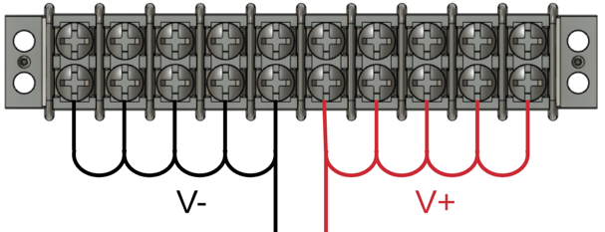

1. **-V** is connected to the other side of the terminal block using a white or black wire. That same colour wire is then used to cascade the -V side of the power to the next 4 terminals.
2. **+V** is connected to one side of the terminal block using a red wire, and then that same colour wire is used to then cascade the +V side of the power to the next 4 terminals.

### Power Cable – 24V Power Supply to PCB

Screw the power cable wires into the terminal block plug as noted below.

Ensure the wire is long enough to reach the PCB when installed.

|  |  |  |
| --- | --- | --- |
| Terminal Block | Wire Color | PCB |
| +V terminal | Red | ○ +24V |
| -V terminal | White | ○ -24V |

This is plugged into the power header connector (#112) installed on the PCB (above).



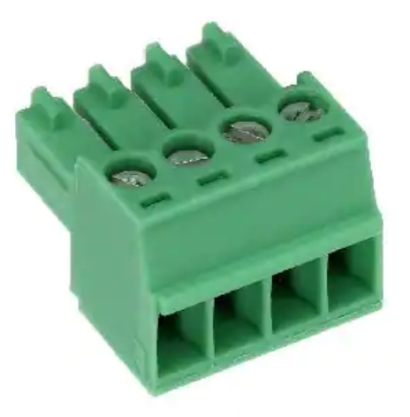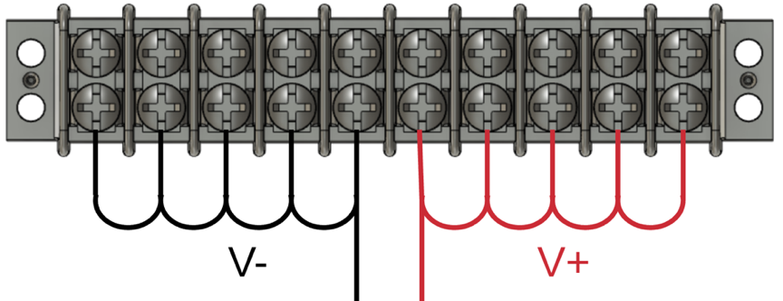

### Power Wiring – DM542T Stepper Motor Drivers (4)

Each of the 4 DM542T stepper motor drivers is connected to the terminal block for power.

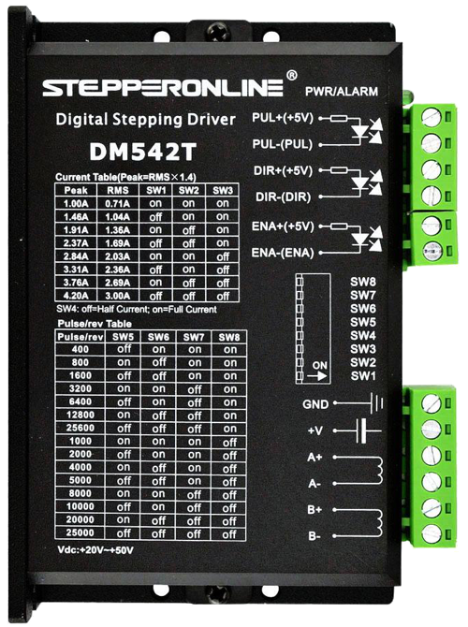

|  |  |  |
| --- | --- | --- |
| Terminal Block | Wire Color | DM542T |
| +V terminal | Red | +V |
| -V terminal | White | GND |

|  |  |
| --- | --- |
| Conductor Type | Stranded or solid copper |
| Conductor Size | 20 or 22 AWG |
| Cable Size | 2 conductors / cable |

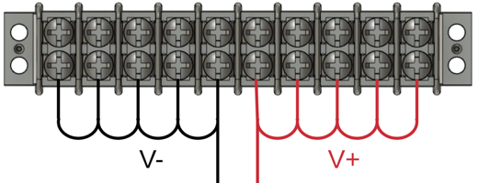

|  |
| --- |
| Section 3 – Stepper Motor Driver Signal Cables |

### Signal Cables – PCB to DM542T Stepper Motor Drivers

Install the pre-crimped ends of the wires into the housing. The other end is connected to the stepper driver as shown below. There are 4 of these.

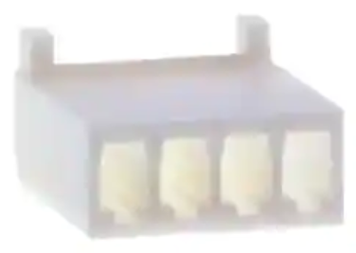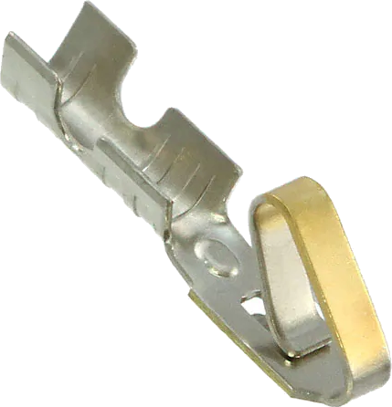

|  |  |  |
| --- | --- | --- |
| DM542T | Wire Color | PCB |
| Pulse + | Black | ○ STEP/PUL |
| Direction + | Red | ○ DIR |
| Enable + | Yellow | ◻ ENA |
| Pulse - | White (GND) * | ○ GND |
| Direction - | White (GND) * |
| Enable - | White (GND) * |



A ratcheting/crimping plier for terminal pins makes the attachment of the terminal ends (#310) much easier.

The one I use is made by [IZOKEE](https://www.amazon.sg/IZOKEE-Ratcheting-Terminals-0-1-1-5mm2-Connectors/dp/B0793T3L2D).

* GND wires tied / bonded together.

**NOTE:** two jumpers will be needed to connect the GNDs on each DM542T. One GND wire comes from the PCB, but it needs to connect to all the negative side connectors on the DM542T driver.

### Signal Wiring –Stepper Motor Drivers to GX-16/4 Jacks (4)

Each of the 4 stepper motors is connected to the stepper motor drivers via GX-16/4 Jacks.

|  |  |  |
| --- | --- | --- |
| DM542T | Wire Color | GX-16/4 Pin |
| A+ | Black | 1 |
| A- | Yellow | 2 |
| B+ | Red | 3 |
| B- | White | 4 |

|  |  |
| --- | --- |
| Conductor Type | Stranded copper |
| Conductor Size | 20 AWG |
| Cable Size | 4 conductors / cable |
| Cable Length | 6 to 8” |



**KEY POINT:** It is best to solder the FX-16/4 jacks to the cables and attach the jacks to the metal plate before attaching the other end to the DM542T stepper motor driver. This is a lot easier.

**NOTE:** When soldering wires to the GX-16 jack, it is a good practice to put a small dab of soldering flux onto the terminal before beginning the soldering. This will help it happen faster, minimizing the chance for damage to the jack.

Put flux here

Don’t put too much

flux onto the terminals as

boiling it off when soldering

could cause the terminal to get

too hot, damaging the jack.

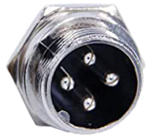

1

2

3

4

## Switch Settings

Set the switches on the DM542Ts as:



|  |  |  |  |
| --- | --- | --- | --- |
| Purpose | Set to | Switch | Setting |
| Current | 2.8A Peak  2.03A RMS | 1 | ON |
| 2 | ON |
| 3 | OFF |
| Half Current | 4 | OFF |
| Pulses / Rev | 6400 | 5 | OFF |
| 6 | ON |
| 7 | OFF |
| 8 | ON |

The current could be set higher with this driver; however, the selected NEMA 23 stepper motor does not need that, so it is set thusly.

**NOTE:** switch settings in the picture are not correct – this is a stock photo from the Internet. Use the settings in the table above.

|  |
| --- |
| Section 4 – Nextion Display Signal Cable |

### Why use a Separate Jack Type for the Nextion Display?

It is a really good idea to have a different connector for the stepper motors than the Nextion touch screen display.

|  |  |  |
| --- | --- | --- |
|  | Nextion Touch Screen Display | Stepper Motors |
| Cable Use | * Serial communications * Power to the display | * Motor stepping, but at a higher voltage |
| Risk if Hooked Up Wrongly | * The higher voltages will probably cause the display to fail. | * The motors will certainly work * May damage the motor. |
| Recommended Connector | * GX-12/4   + Being 12mm in diameter makes the plug not able to connect to the GX-16/4 jack. | * GX-16/4   + Being 16mm in diameter makes the plug not able to connect to the GX-12/4 jack. |
| Optional Connectors | * Could use a GX-16 with more than 4 connectors (e.g., GX-16/5). The additional pins will just be unused, but this would prevent plugging the plug into the wrong jack. * RJ-45 | * n/a |

### Signal Cable – PCB to Nextion Display

The Nextion touch screen is connected to the PCB via GX-12/4 connector.

**KEY POINT:** It is best to

1. Solder the jack to the cables
2. Install the jack into the 2-gang plate.
3. Once that is in place, then insert the pre-crimped ends into the housing.

This is a lot easier.

Green Wire

TX

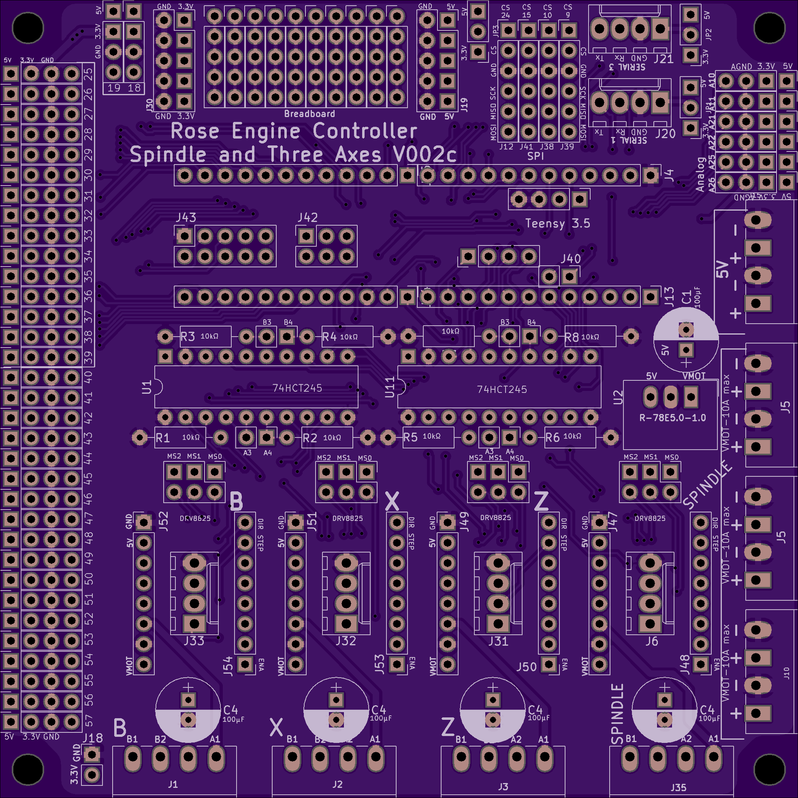

**NOTE:**

* Tx on the PCB is connected to Rx on the Nextion HMI display.
* Rx on the PCB is connected to Tx on the Nextion HMI display

Rx

Tx

**Nextion HMI Display**

Tx

Rx

**PCB**

White Wire

GND

Blue

Wire

RX

Orange

Wire

+5V

Tx = 1

Rx = 3

GND = 4

+5V = 2



### Signal Cable – PCB to Nextion Display



Install the pre-crimped wires into the housing. There are 4 of these.



Orange

Wire

+5V

White Wire

GND

Blue

Wire

RX

Green Wire

TX

|  |
| --- |
| Section 5 – Limit Switch Signal Cables |

### Signal Wiring – PCB to 3.5mm Audio Jacks for Limit & Home Switches

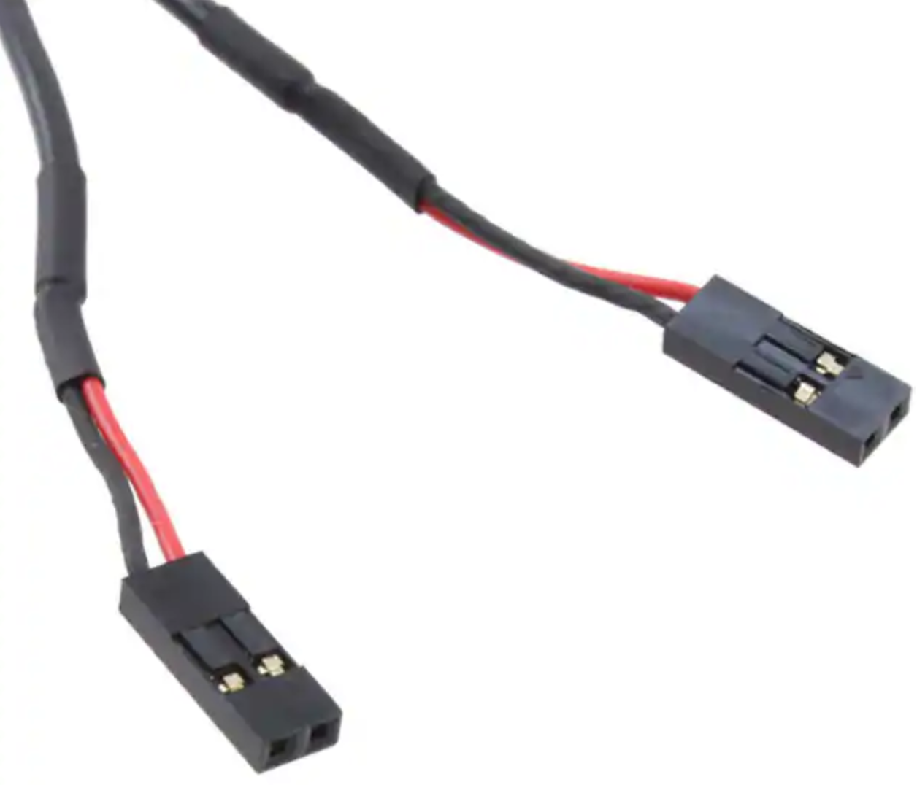

The limit switches are connected to the PCB via a 3.5mm (1/8”) audio female jack. 6 pins on the Teensy are used (one for each limit switch). These can be any of the pins between 25 and 39.

The cable used is half of part #305.

|  |  |  |
| --- | --- | --- |
| PCB | Wire Color | Audio Jack |
| ○ pin # | Red | Tip / pin 2 |
| ○ GND | Black (or White) | Sleeve / pin 1 |

Actual length is 9 ¾”

(only one jack is shown)

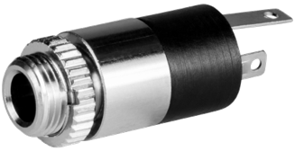

2 - Tip

1 - Sleeve



**NOTES:**

1. Most audio jacks that are available are stereo with 3 connectors. Only 2 are needed, so the 3rd one will go unused.
2. Experience has shown that it is a good practice to ensure a mono plug will work correctly for the way you have soldered the connections.

**KEY POINT 2:** It is a really good idea to label each cable with the pin it is used for.

**KEY POINT 1:** The sleeve must be connected to ground (GND). Typically, this is pin 1, but check based on the jack you are using.

Connect the cables to the header pins. The recommended pins are noted below, but any between 25 and 39 can be used.



**25**

**26**

**27**



Outside = GND = Black wire

Inside = pin # = Red wire

**NOTE:** On the V002i PCB, the wires should be plugged into:

* 18 & 19 – One will be used for Quick Stop
* 34 – 39 – Will be used for limit switches

**28**

**38**

**39**

|  |
| --- |
| Section 6 – Final PCB Steps |

### Mounting the PCB to the MDF Board

The Teensy microcontroller is installed onto the PCB as shown in the picture to the right.

**NOTE:** Recommend using a Sharpie to write on the top of this area what type of Teensy is being used (e.g., 3.5 or 3.6). That will be helpful when upgrading later.

The two 74HCT245 integrated circuits are installed as shown in the picture to the right. Note that the indicating mark should be on the left side as shown here.

A microSD extension cable, 8 to 12 inches long, is useful. The male end can be put into the Teensy’s microSD slot, and the female end can then be hung out of the case. This makes it easier to access files for the screens where that function is possible.

**MicroSD Extension Cable**

|  |
| --- |
| Section 7 – Stepper Motor Cables |

Each of the stepper motors is connected to the stepper motor drivers via GX-16/4 plugs. Stepper motor wire colors shown are for the StepperOnline motors. Check that the one you use matches for the connection needed.

Yes, I am a Packers fan

|  |  |  |  |
| --- | --- | --- | --- |
| Stepper Motor | Stepper Motor Wire | Cable Wire Color | GX-16/4 Pin |
| A+ | Black | Black | 1 |
| A- | Green | Yellow | 2 |
| B+ | Red | Red | 3 |
| B- | Blue | White | 4 |

|  |  |  |
| --- | --- | --- |
| Conductor Type | | Stranded copper |
| Conductor Size | | 20 AWG |
| Cable Size | | 4 conductors / cable |
| Cable Length | |  |
|  | Spindle | 4 ft |
|  | Others | 3 ft, or as desired |

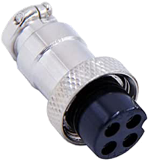

1

2

3

4

B-

B+

A-

A+

**GX-16/4**

Put a ¾” long piece of shrink file onto each one of the stepper motor wires before connecting it to the cable 5 wires.

Connect the cable wires to the stepper motor wires using a lineman’s splice (AKA, the Western Union splice, and shown to the right), and then solder the two together.

Heat the shrink file tubing around each of the joints to insulate it from the other things it could touch.

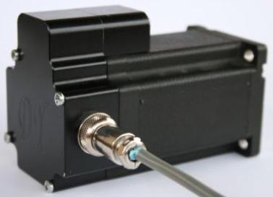Alternatively, you can add a back cover to the stepper motor. This gives a secure way to attach the signal wires to the motor. These are available from a number of sources, and they can even be 3D printed. Look for one online using the term “stepper motor back cover”.

In this case, connect the stepper motor to the GX-16/4 jack as:

|  |  |  |
| --- | --- | --- |
| Stepper Motor | Stepper Motor Wire | GX-16/4 Pin |
| A+ | Black | 1 |
| A- | Green | 2 |
| B+ | Red | 3 |
| B- | Blue | 4 |

|  |
| --- |
| Section 8 – Assembly of the Nextion touch screen Box |

## Attach Nextion Display to the Bezel

One hole is printed into the back side of the bezel for attaching the Nextion touch screen (circled in red to the right). That one needs to be enlarged using a #39 drill to a depth of 1/8”.

Attach one corner of the Nextion touch screen using an M3 Thread Forming Screw, then center the HMI. Drill the other 3 corners, and then attach the display using the remaining M3 Thread Forming Screws.

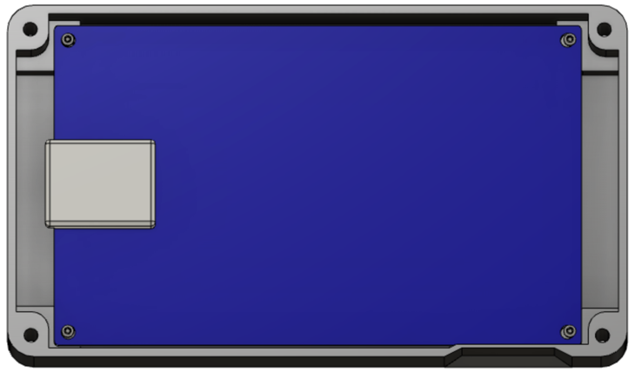

Note that the Nextion is inserted upside down. This is because the microSD card slot is then pointed down. And the microSD card slot is accessible so that upgrades can be done without having to disassemble the whole system. (The slot for inserting the microSD card is in the base, not the bezel.)

### Attach Parts to the Base

Attach the 4 magnets to the base’s bottom. There are 4 insets in the base for these.

If the screws protrude into the base, take some efforts to grind or file those sharp points down.

### Insert the Heat-Set Inserts

There are two options here:

1. Using a heat gun, insert each of the heat-set inserts into the corners of the base. These would then be used to attach the top of the case using the 4-40 screws (#403).  
     
   If you plan to disassemble the box and reassemble it quite a bit, this is probably the way to go. Otherwise, take option #2 (it is much easier.
2. Do nothing at this point, and attach the top using thread forming screws (#410)

### Add Wire Cord Grip

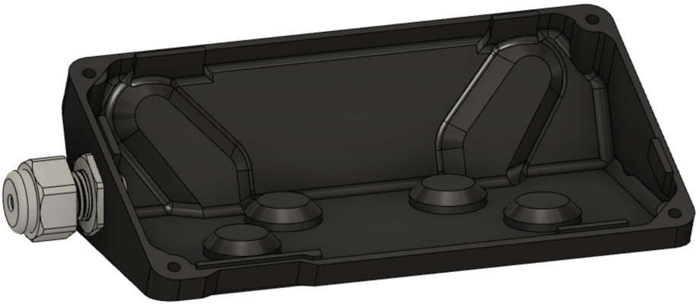The cord grip is used to ensure the signal wire does not pull against the Nextion display.

Depending on the printing, you may need to drill the whole with a ½” bit to ease the installation.

### Signal Wiring – PCB to GX-12/4 or RJ-45 Plug for Nextion Display

|  |  |  |  |  |
| --- | --- | --- | --- | --- |
| Nextion Connection | Nextion Wire Color | CAT 5  Wire Color | GX-12/4  Pin | RJ-45  Pin |
| RX | Yellow | White/Green | 1 | 1 |
| +5V | Red | Green | 2 | 2 |
| TX | Blue | White/Orange | 3 | 3 |
|  |  | Blue |  | 4 |
|  |  | White/Blue |  | 5 |
| GND | Black | Orange | 4 | 6 |
|  |  | White/Brown |  | 7 |
|  |  | Brown |  | 8 |

The Nextion touch screen is connected to the main box via a GX-12/4 or RJ-45 connector.

White/Green

1

1

White/Orange

3

3

White/Blue

5

White/Brown

7

Using a piece of CAT 5 (or greater) wire, 8 feet long, make the connections to the HMI’s connector (supplied by the vendor) as shown to the right.

**NOTE 1:** Be sure to put the cable thru the cord grip (#212) before attaching both ends.

**NOTE 2:** Be sure to add a short piece of shrink tubing to the CAT 6/5 wire before finishing the soldering to the



1

3

2

4

**GX-12/4**

GX-12/4 plug (#216) This shrink tubing is needed to secure

the plug to the Wire (#301).

Put a ¾” long piece of shrink file onto each one of the Nextion wires before connecting it to the CAT 5 wires.

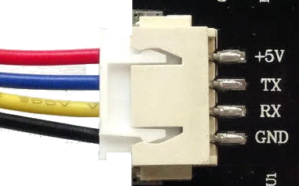

**Nextion Display**

Connect the CAT 5 wire to the Nextion wires using a lineman’s splice (AKA, the Western Union splice, and shown to the right), and then solder the two together.



**Lineman’s Splice**

Heat the shrink file tubing around the joint to insulate it from the other things it could touch.

|  |
| --- |
| Section 9 – System Setup and Program Loading |

Use the web page noted below to load the programs into the Teensy and the Nextion, and then load the initial configuration into the Teensy.

[](https://mdfre2.colvintools.com/NextionUserGuide-Upgrading.html)

<https://mdfre2.colvintools.com/NextionUserGuide-Upgrading.html>

If you are looking for that book on the MDF Rose Engine Lathe 2.0 Library, it is just like the book shown to the right.

|  |
| --- |
| Section 10 – Finishing It Up |

Before screwing the bezel to the base, check to be sure everything works. To do that, you will need to use the instructions in the next section to load the programs into all the pieces.

or

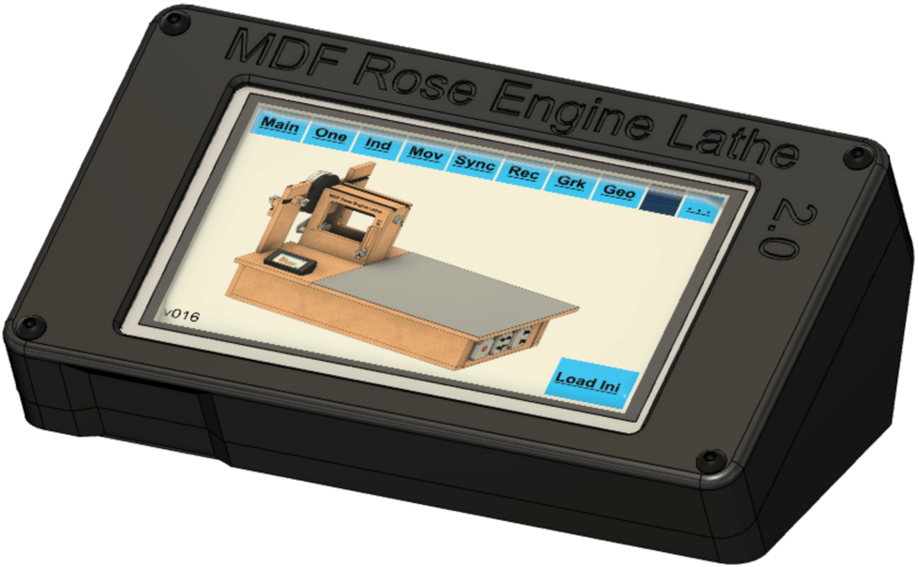

If it works, screw the two pieces together.

If you took the option to use the heat set inserts back on pg. 37, then attach the lid using four #4-40, ¾” long screws (#403).

Otherwise, attach it using 4 thread-forming screws (#410).

When finished and powered on, it will look like the picture to the right.

# Optional Configurations

If you wish to change the designs built into this system, options are outlined below. ***We do not support systems with such changes, so the user must be aware that they will be responsible for their own technical support.*** These options are only provided for the sake of completeness and transparency.

## Option 1: Less Functional Model

|  |  |  |  |  |
| --- | --- | --- | --- | --- |
|  | **Configuration** | | | |
| **Component** | **Spindle Drive Only** | **+ Z Axis** | **+Z & B Axes** | **+Z, X, and B Axes** |
| 10 KΩ Resistors | 4 | 4 | 8 | 8 |
| 74HCT245s &  20-pin DIP sockets | 1 | 1 | 2 | 2 |
| DM542T Stepper motor drivers &  GX-16/4 Jacks | 1 | 2 | 3 | 4 |

Some have expressed the desire to build a system which is not as fully functional as outlined in this document. For example, they only want to drive the spindle.

That is very doable but is not an option we will be providing. The components which can be left out when building the system are outlined in the table below.

Regarding limit switches, none are truly required. These can be added later as desired. If not used, the 3.5mm audio jacks are not needed.

### Recommendation

Except for the DM542T Stepper Motor Drivers, there really is not any significant cost advantage to taking this approach. So, if you do desire to make such a change, consider populating the Printed Circuit Board fully (8 resistors and two 74HCT245s). The DM542Ts can be added when you later want to expand to use them.

## Option 2: Alternative Stepper Motor Drivers

The printed circuit board was developed to use either

* the DM542T external drivers outlined above, or
* the Pololu DRV8825 stepper motor drivers which would be attached to the board using header sockets.

### Advantages to Using the Pololu DRV8825

1. DRV8825s are about 1/3 the cost of an external driver (i.e., the DM542T).
2. Having the DRV8825s mounted to the printed circuit board makes for a smaller physical footprint, enabling it to be installed easily inside the lathe’s bed carcass.
3. The power draw for this configuration is lower, so a different (& potentially less expensive) power supply is possibly available.
4. There is less cabling to be done.

### Disadvantages of Using the Pololu DRV8825

1. DRV8825 chips are limited to a max 1.5 A (vs. 4.2 A for the DM542T drivers).
   1. This can necessitate the need for different, more expensive stepper motors. The cost of these different motors can erode the savings for not using the external stepper motor drivers (DM542T).
   2. It is easy to overload the DRV8825 chips and cause them to fail.
   3. It is easy to overload the DRV8825 chips and they in turn can cause other components to fail (e.g., the Teensy).
2. DRV8825 chips get hot when used, so fans must be attached to them to ensure they do not overheat. And the user will need to replace the fans when they fail.
3. Future deliverables (e.g., a curvilinear slide and a spherical slide) for the MDF Rose Engine Lathe 2.0 will be tested to ensure compatibility with the design from above. If the add-on devices do not work with the changed configuration, the owner/builder will be responsible for accommodating the necessary changes.

### Recommendation

Unless you are an electrical / automation engineer or have substantial experience in this space, the design outlined with external stepper motor drivers (DM542Ts) will be easier to implement over the long term.

## Option 3: Different Microcontroller

The printed circuit board was developed to use either

* the Teensy 3.5 outlined above, or
* the Teensy 3.6.

The Teensy 3.6 is 50% faster than the 3.5; however, it will only accommodate 3.3V whilst the Teensy 3.5 will accommodate 5V. Using the 3.5 helps ensure you don’t burn out the microcontroller.

As for Teensy 4.0 or 4.1, the library of functions needed to control the stepper motor drivers is not yet complete for those boards. We will re-evaluate those over time.

### Recommendation

Unless you are an electrical / automation engineer or have substantial experience in this space, the design outlined with a Teensy 3.5 is recommended.

## Option 4: Different Display

The control system was designed for a 4.3” Nextion display. We provide the code for these displays:

* 4.3” Enhanced display,
* 5” Intelligent display, and
* 7” Intelligent display.

These all have the same resolution (800 x 600), so the screens can be displayed with no re-programming.

That said

1. The Intelligent displays require re-wiring the PCB (if you are using the V002c board and are using the Teensy 3.6), and
2. We do not have a 3D printable case for the 5” or 7” displays at this time.

### Recommendation

Use the Nextion 4.3” Enhanced display.

# Document Version History

|  |  |  |
| --- | --- | --- |
| Ver | Date | Comment |
| 3.1 | 19 Oct 21 | * Added support for the new **Rose Engine Controller Spindle and Three Axes V002i** printed circuit board. |
| 3.0 | 19 Aug 21 | * Original document split into 3 parts to allow for different case configurations to be handled easily. |
| 2.1 | 14 Aug 21 | * Changed pins used for limit switches * Added information regarding different Teensy and Nextion displays. |
| 2.0 | 13 Jun 21 | * This document incorporates changes to the way cables are attached to the PCB. It now shows how to use connectors in lieu of soldering the wires directly to the board. |
| 1.4 | 10 Mar 21 | * Reorganized a few steps to follow better flow of work. * Added notes on using GX-12/4 connector for Nextion display. * Updated instructions for loading software to reference web site. * Also added a few minor other tweaks. |
| 1.3 | 01 Jan 21 | * Added item numbers for optional build using a Pololu Tic (this is a separate document). * Renamed Document |
| 1.2 | 15 Dec 20 | * Added parts to the bill of materials * Added details on the installation of the 3.5mm phono jacks. |
| 1.1 | 10 Dec 20 | * Added details for optional configurations. * Added information for attaching the stepper motor to the headstock |
| 1.0.2 | 07 Dec 20 | * Updated p/n for item #204; also updated p/n & qty for item #102. * Added note on soldering on 3.5mm jacks first. |
| 1.0.1 | 05 Dec 20 | * Updated commentary about stepper motor needed. * Added information about stepper motor mount, pulleys, and belt. * Updated drawing dimensions. |
| 1.0 | 01 Dec 20 | Initial document |

To the extent that material may appear to be infringed, we assert that such alleged infringement is permissible under fair use principles in U.S. copyright laws. If you believe material has been used in an unauthorized manner, please contact me at [ColvinTools@Gmail.com](mailto:ColvinTools@Gmail.com).

The layout of the Printed Circuit Board (PCB) is copyright Ed French and is used with his permission.

Permission is not granted to manufacture these for sale.